FIRST TERM EXAMINATION
SUBJECT: COMPUTER STUDIES/ICT CLASS: SS 3 Time: 1:30 HRS
Instruction: Answer all questions in section A and B.
SECTION A (Objective Test: Choose the correct option from a – d) (30 marks)

- …………… is a device that connects all the other devices in a star network together.
A. Modem B. Bridge C. Network card D. Hub

- Which of the following software will be loaded first to the memory when the computer is switched on?
A. Spreadsheet B.Word processor C. Operating system D.Web page browser

- A computer’s primary memory is also known as the
A. secondary memory B. Main memory C. Auxiliary memory D. Central Processing Unit.

- The acronym ARCNET stands for
A. Artificial Connector Network B. Attached Resource Computer Network C. Analytical Resource Computer Networking D. Architectural Network.

- Which of the following files is an image?
A. rain.jpeg B.image.doc C. picture.exe D. project1.img

- A manager wants to project profit for next year. Which of the following programs should he use?
A. Spreadsheet B.Word processor C. Graphics package D. Presentation software
- Which of the following strategies cannot effectively prevent a computer from being infected by viruses?
A. Use virus scanning program. B. Refuse to use pirated software. C. Switch off computers that are not in use. D. Do not open emails coming from questionable sources.

- …………….. is an assembly of two or more electrical conductors used for transmission of electrical power.
A. Coaxial cable B. Power cable C Telephone cable D. Fibre optics

- What is the file name for c:\myfiles\CS\application.doc?
A. CS B.doc C.myfiles D. application

- The feature in word processing that enables users to type words continually without pressing the ENTER key when the cursor reaches end of each line is
A. Find. B. Replace. C. Word-wrap. D. Mail-merge.

- Which of the following buttons will you use to retrieve a document from a location?
A. Edit B.Open C. Save D. View

- The function =AVERAGE(B2:B8) in cell B9 has been copied and pasted to cells C9 to K9 in spreadsheet. Which of the following formulas would be displayed in cell D9?

A. =AVERAGE(C9:K9) B.=AVERAGE(D2:D8) C. =AVERAGE(B2:B8)
D. =AVERAGE(D2:D9)
- Which of the following is NOT an object found in a relational database?
A. Form B.Table C.Spreadsheet D.Report

- A formula in spreadsheet does not include
A. labels. B. values. C. cell reference. D. mathematical operations.

- Which of the functions below would you use to find the highest number from a set of numbers?
A. MIN B.MAX C. SUM D. COUNT

- Which of the following field types, in database, can only have two possible values?
A. Text B.Date C. Number D. Boolean

- A field which uniquely identifies a record in a database is referred to as
A. a record. B. information. C. a foreign key. D. Primary key.

- A set of instructions specifying how records would be extracted from a set of records is known as a
A. table. B. query. C. report. D. macro.

- The acronym SQL stands for
A. Standard Query Language. B. Structural Query Language. C. Standard Question Language. D. Sequential Question Language.
20. http://www.learnafrica.com/branch is an example of a/an
(a) IP address (b) URL (c) DNS (d) e-mail address
21. …………… is a collection of computers and peripheral components interconnected by communication channels.
A. Networking B. Information Transmission C. Transmission D. Linkage
22. Sam wants to enter students’ test marks into a spreadsheet application. Which of the following keys will make the data entry faster?
A. Control keys B.Function keys C. Document keys D. Numeric keypad
23. …………… can be referred to as a collection of multiple LANs
A. LAN B. WAN C. PAN D. SAN
24. …………… is a set of networks, that is under the control of a single administrative entity which gives access only to authorised users.
A. Ethernet B. Extranet C. Enternet D. Intranet
25. ………………… defines the formats and the set of rules for exchanging information in a network.
A. Protocol B. Guidelines C. Transfer Media D. Topology
26. The following are network devices EXCEPT
A. Modem B. Firewall C. Hub D. Switch
27. Which of the following can be said to be a benefit of computer networks?
A. They allow easy collaboration B. It enhances digital divide C. They are always easy to set up D. They are moderately expensive
28. …………… is an example of a transmission media.
A. Firmware B. Firewall C. Optical fibre cable D. Network OS
29. Which of the following is NOT an example of wireless technologies?
A. Terrestrial microwaves B. Transmission satellite C. Infrared communication D. Coaxial cable connection
30. The following are computer networks EXCEPT
A. Star B. Token-ring C. Computer tree D. Bus
31. The computer network that enables communication among computers and other devices close to an individual is called ……….
A. LAN B. MAN C. WAN D. PAN
32. ………........ uses a high frequency radio technology similar to digital cellular and a low-frequency radio technology within a limited area.
A. LAN B. WLAN C. MAN D. Satellite
33. Who developed the Word Wide Web?
A. Adams Smith B. Bill Gate C. Jeremiah Lee Bernes D. Timothy Berners Lee
34. Which of the following software is specially designed for website designs?
A. Thunderbird B. Linux C. Dreamweaver CS D. Adobe Photoshop
35. A …………….. topology is designed in such a way that each node is connected directly to a central network hub.
A. Mesh B. Linear C. Star D. Central
36. …………….. is a system of internet servers that support hypertext and multimedia to access several internet protocols on a single interface.
A. World Wide Web B. Hypertext C. Homepage D. Protocol
37. ………………. Provides basic/general information about the purpose and content of a website.
A. Website B. Webpage C. Server D. Homepage
38. …………………. is an address identifying the location of a file on the internet.
A. WWW B. URL C. Protocol D. Web Address
39. ………….. is the medium through which information transverses from one network device to another.
A. Waves B. Hyperlink C. MODEM D. Cable
40. Cables are ……………………..
A. electrical conductors covered by insulators B. Insulators covered by electrical conductors C. Conductors covered by electrical sheaths D. Solar conductors
41. An audio jack cable is used for connecting ……………….
A. computer machine B. mobile devices C. audio devices to computer D. audio devices to visual devices
42. The diagram shown below is referred to as ……..
A. HDMI cable B. Monitor cable C. RCA connector cable D. Printer cable
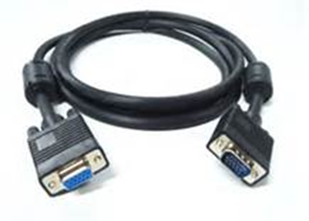
43. HDMI cables provides …………………….
A. only audio transmission B. only video transmission C. both audio and video transmission D. video transmission through multiple single cable
44. ………… involves rearranging the records in either ascending or descending order
A. Modifying B. Translating C. Sorting D. Organising
45. ...................... can be defined as an organised collection of related records.
A. Database B. Table C. Manual D. Query
46. Which of the following is a example of database package?
A. My SQL B. Java C. C++ D. Macromedia flash
47. Who was the first person to propose the idea of relational database structure?
A. Cole Edgar B. Michael Faraday C. Charles Babbage D. Edgar Codd
48. A table is divided into …………..
A. length and breadth B. field and record C. rows and column D. Header and footer
49. Which of the following is NOT a data type in a database application?
A. Date B. Text C. Numeric text D. Currency
50. Which of the following fields is best suitable as a primary key?
A. Surname B. First name C. Phone number D. e-mail address

SECTION B: Answer ANY three questions from this section. QUESTION ONE is COMPULSORY.
QUESTION ONE
(a) On her first day at work as a school librarian, Sera notices that book records are kept manually using a card system. She suggests to the Principal that they use a database. State TWO reasons why using a database would be helpful to the librarians. (2 marks)

(b) Give TWO examples of a database program. (2 mark)

The Admin Officer of Deeper Life High School uses a database to keep records of his employees as shown in the table below. Use this information to answer the questions that follow.
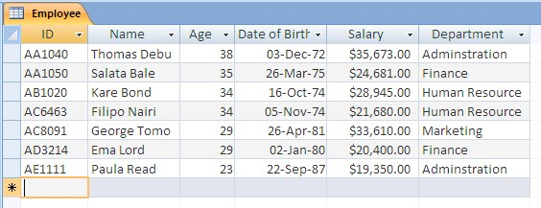

(c) How many fields are there? (1mark)
(d) Name an appropriate data type for (i) ID (1mark) (ii) Age (1mark)
(e) SELECT Name, Department
FROM Employee
WHERE Salary > 25000;
Write down the records that will be displayed as a result of the above query? (3 marks)

QUESTION TWO
(a) In the spaces below, write the name of the components and describe ONE function of each.
Component | Name | Function
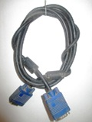
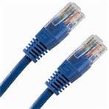
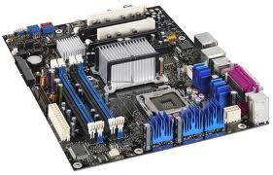
(6 marks)

(b) Enumerate FOUR basic operations that could be performed in Database. (4 marks)

QUESTION THREE
Five definitions are given on the left hand side of the diagram below. Five computer terms are shown on the right.
By drawing arrows, connect each definition to the correct computer term.
Website that allows virtual communication; user joins a site and invites friends who, in turn, invite their own friends
CHATROOM

Technology that allows telephone calls to be made using computer networks, such as the internet.
SOCIAL NETWORKING

TAGGING
Online “place” where a group of people get together and discuss a number of topics

Software that allows any user to freely create and edit a web page using their own web browser
VoIP

WIKI
Marking, saving and archiving certain websites or items (such as photos); for example, it allows users totrack and organise favourite websites or photos.

, allowing mu

(5marks)

(c) Write short notes (about 5 lines) on the following; (i) Database Management System (2marks) (ii) Routers (2marks) (ii) Modem (1mark)

QUESTION FOUR
(a) What do you understand by the term ‘Networking’?(2marks)

(b) Highlight FIVE benefits of networking.(5marks)

(c) Itemize THREE network devices and their uses. (3marks)

SECTION C: PRACTICAL SESSION

(20 marks)
Answer ALL TWO questions. Use computer to answer all questions. Print out the hard copy.
QUESTION ONE:
(a) (i) Use Ms-Access to generate an Electronic Address book for students in your school. The table should contain the following fields:
- Serial Number
- Last Name
- First Name
- Sex
- Date of Birth
- Class
- State of Origin
- Telephone number
(ii) Enter ten records into the table created based on the data type assigned to each of the fields above. (Note: Your name should be first on the list).
(iii) Apply font type “Century” and font size 14 to all the records produced.
(iv) Change the orientation of the paper page to landscape with margin one inch (1”) for top and bottom
(v) Save the table with your name and then print it out.

(b) (i) State any two precautions taken in performing this task
(ii) What is the function of primary key in Ms-Access
(iii) What is record?
(iv) Mention four objects found in Ms-Access

QUESTION TWO:
Carefully study the diagrams below and answer the questions that follows;

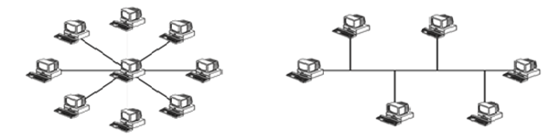
A
B

(a) Name the types of network topology shown in diagrams A & B above.
(b) State THREE advantages of topology A over topology B
(c) Enumerate THREE disadvantages of connecting computers in a network

